“Expert Cloud Consulting” -

SOP | Migration
09.December.2024
version 1.0
─
Contributed by Tejal Kale
Approved by Akshay Shinde (In Review)
Expert Cloud Consulting
Office #811, Gera Imperium Rise,
Hinjewadi Phase-II Rd, Pune, India – 411057

“Expert Cloud Consulting”

Migration of AWS Database

1.0 Contents

1.0 Contents 1
2.0 General Information: 2
2.1 Document Purpose 2
2.2 Document References 2
2.3 Document Overview 3
3.0 Steps / Procedure 4
3.1: Installation of Discovery agent 4
3.2: Setting up replication template 4
3.3: Setting Up Post-Launch Actions 5
3.4: Installation of replication agent 5
3.5: Replication - Launch test instance to finalise cutover 7
3.5.1: Create or Edit a Launch Template: 7
3.5.2: Verify Launch Template: 8
3.5.3: Launch test instance: 8
3.5.4: Transitioning from Test Instance to Cutover Instance: 8
3.5.4: Finalize Cutover: 8
5.0 Annexure - I 9

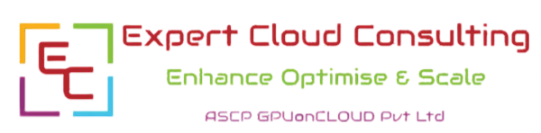

2.0 General Information:

2.1 Document Purpose
This document provides a step-by-step guide for migrating a MySQL database from one Amazon
RDS instance to another using AWS Database Migration Service (AWS DMS). The purpose of
this migration is to ensure a seamless, secure, and efficient transfer of database objects and data
while minimizing downtime.

2.3 Document Overview

This document provides a detailed, step-by-step guide for migrating a database using AWS Database Migration Service (AWS DMS). The migration process includes setting up two Amazon RDS instances (MySQL), creating databases and tables, inserting data, configuring replication, and performing data migration.

3.0 Prerequisites
- Before proceeding, ensure you have:
- An AWS account with necessary permissions.
- Installed XAMPP for managing MySQL databases.
- Created a VPC and Security Group in AWS.
- Enabled Inbound/Outbound rules for MySQL connections.

Step 1: Create Two Amazon RDS Instances (Source & Target Databases)

We will create two MySQL RDS instances—one as the source database and another as the target database.

- Steps to Create RDS Instances:
- Login to AWS Console → Navigate to RDS.
- Click on Create Database.
- Select Database Creation Method: Choose Standard Create.
- Choose Engine Type: Select MySQL.
- Choose Edition: Select MySQL Community.
- Set Deployment Option: Choose Amazon RDS.
- Configure Database Settings:
  - DB Instance Identifier (Source): source-mysql-db
  - DB Instance Identifier (Target): target-mysql-db
  - Username: admin
  - Password: yourpassword
- Choose Instance Class: Select db.t3.micro (Free Tier eligible).
- Storage: Set storage type to General Purpose SSD (gp2).
- Set VPC & Security Group: Ensure it's publicly accessible if connecting externally.
- Create Database and wait for the instances to be available.
Two MySQL RDS instances are now created.

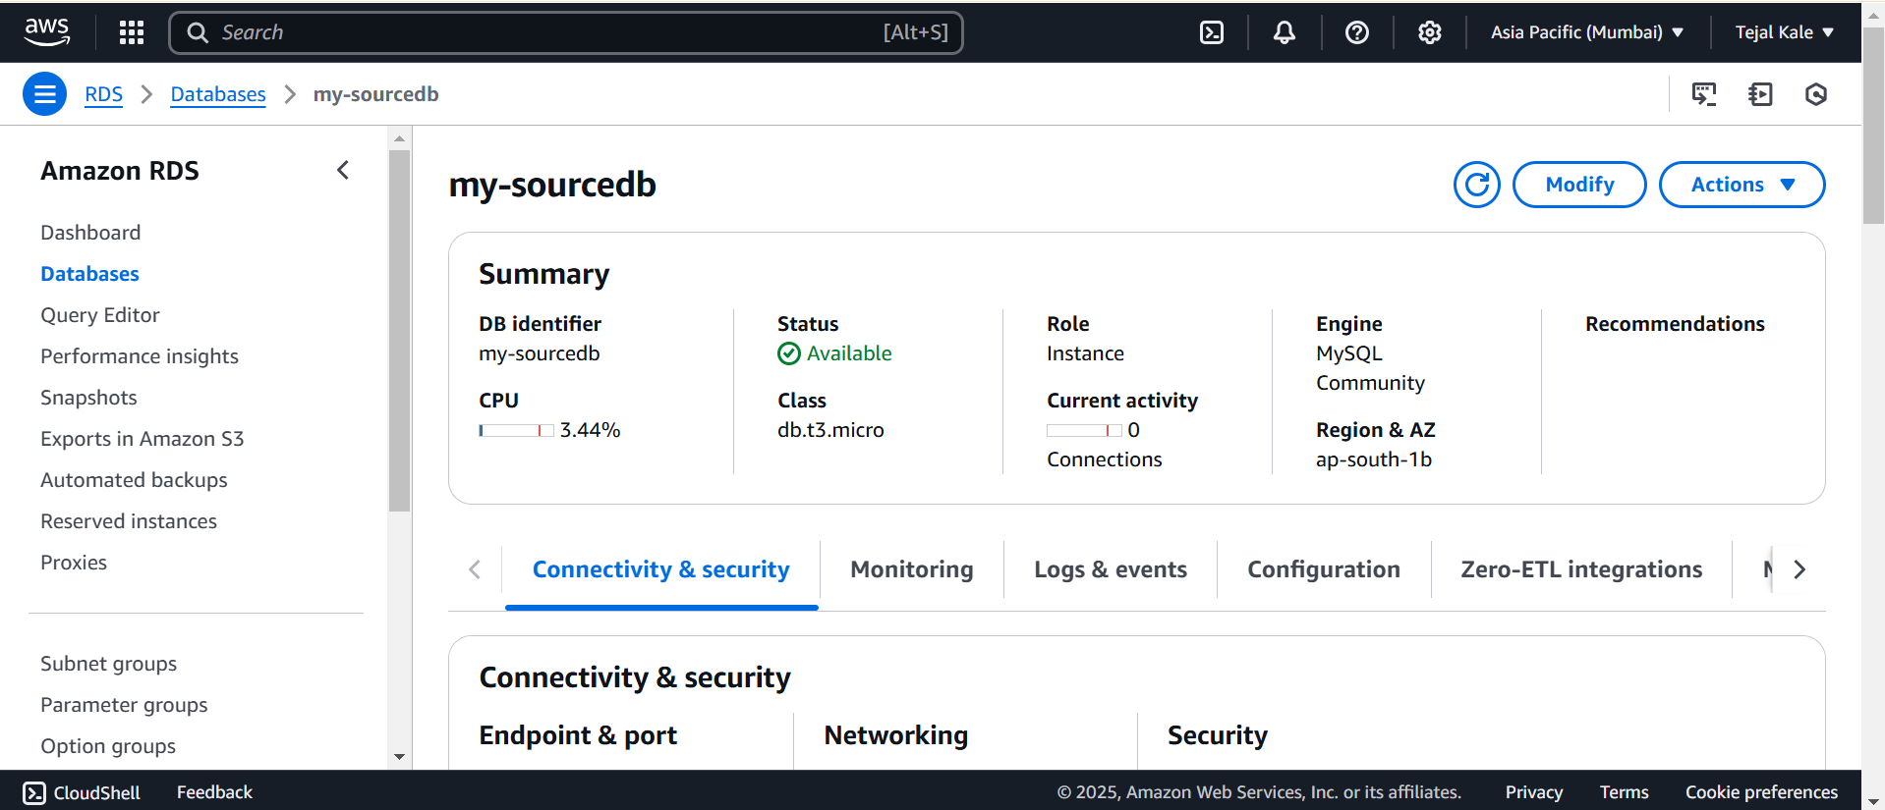
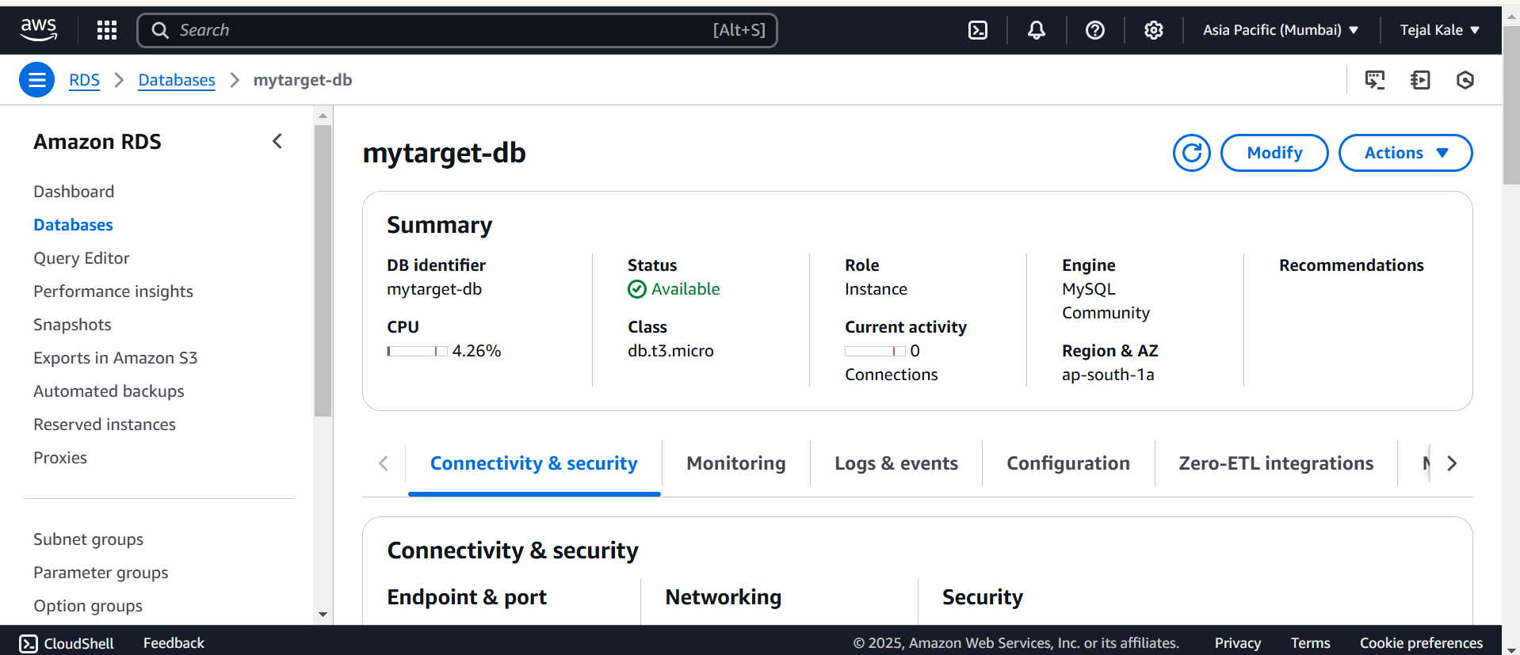

Step 2: Connect MySQL RDS Using XAMPP (phpMyAdmin)
To interact with RDS MySQL databases using XAMPP phpMyAdmin, follow these steps:
Steps to Connect RDS to XAMPP phpMyAdmin:
- Open XAMPP Control Panel and start Apache & MySQL.
- Go to phpMyAdmin (http://localhost/phpmyadmin).
- Click on New Server in phpMyAdmin.
- Enter the RDS Endpoint:
  - Server Hostname: source-mysql-db.xxxxxxxx.us-east-1.rds.amazonaws.com
  - Username: admin
  - Password: yourpassword
- Click Save and Connect.

Step 3: Configure Databases, Tables, and Insert Data
After RDS instances are available, create databases and tables in the source RDS instance.

Create Database & Table in Source RDS:

Connect to MySQL RDS (Source Instance):
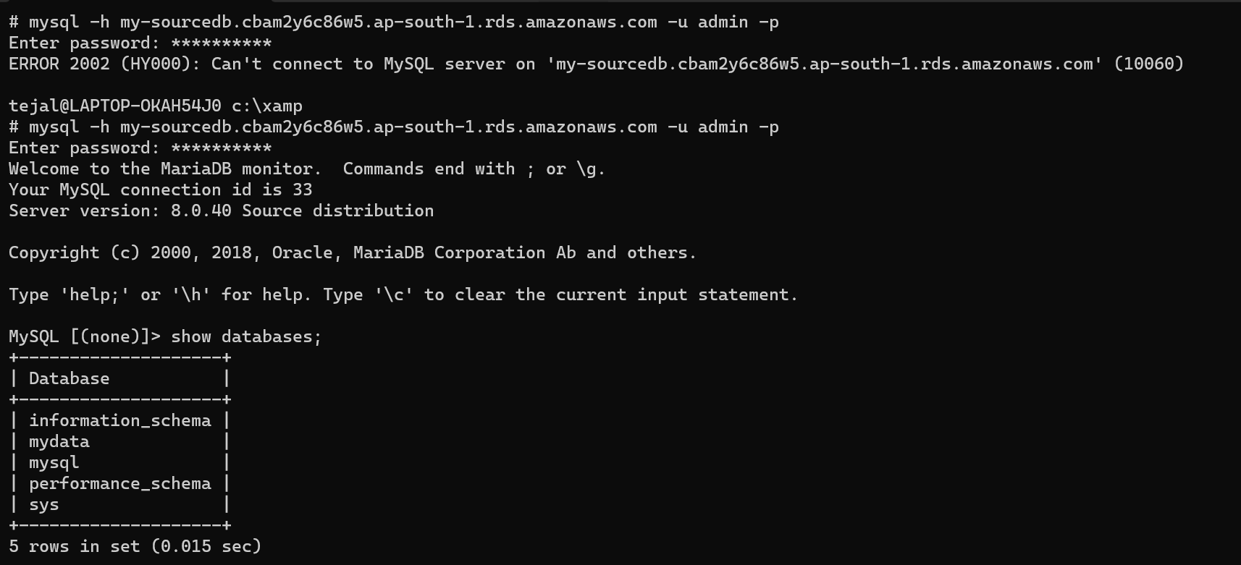

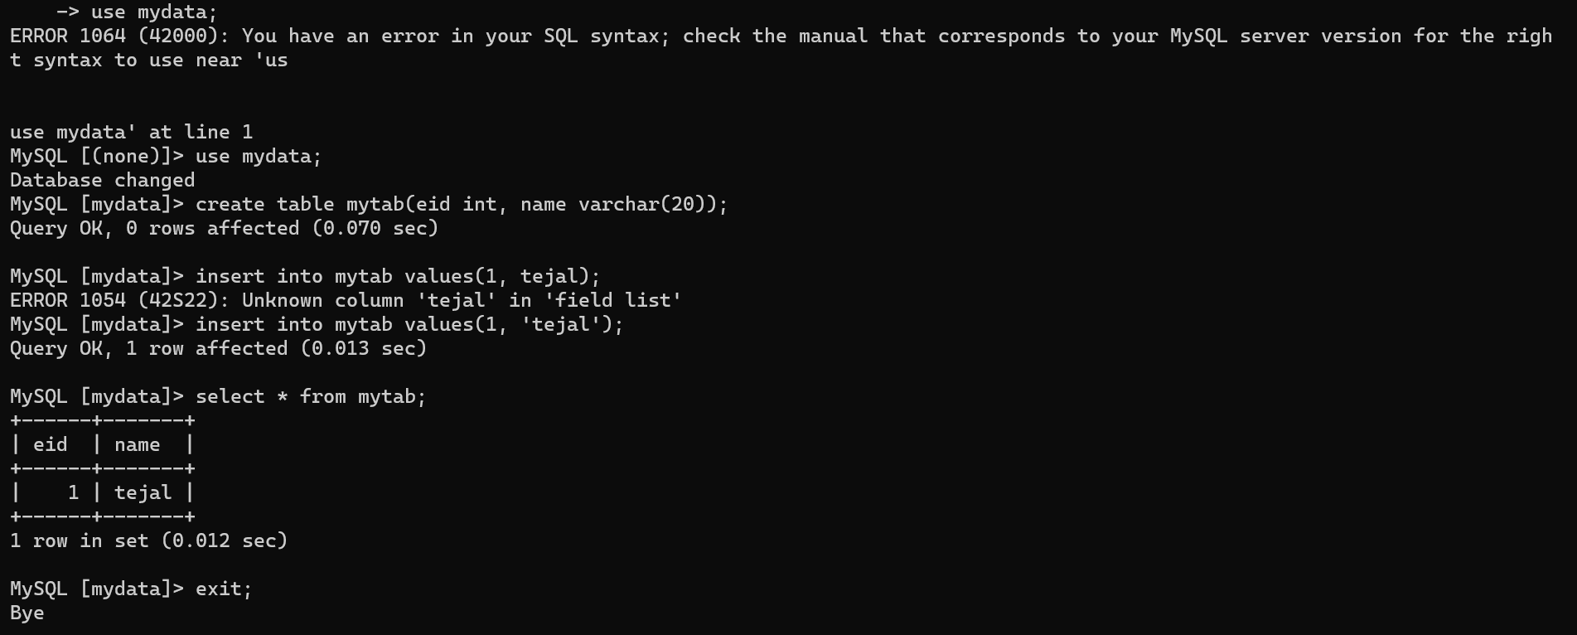

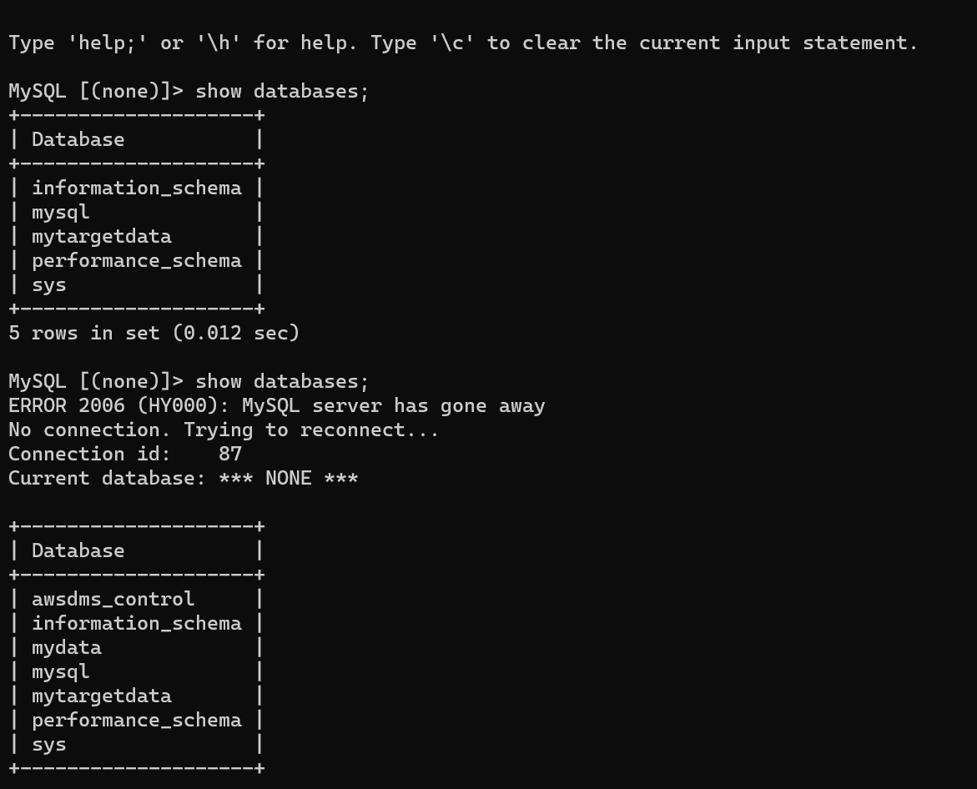

Step 4: Create a Replication Instance in AWS DMS
The replication instance manages the migration process between the source and target databases.
Steps to Create Replication Instance:
- Navigate to AWS DMS → Click Replication Instances.
- Click Create Replication Instance.
- Set Name: mysql-replication-instance.
- Choose Instance Class: dms.t3.micro.
- Choose VPC: Same as your RDS instances.
- Click Create Replication Instance.
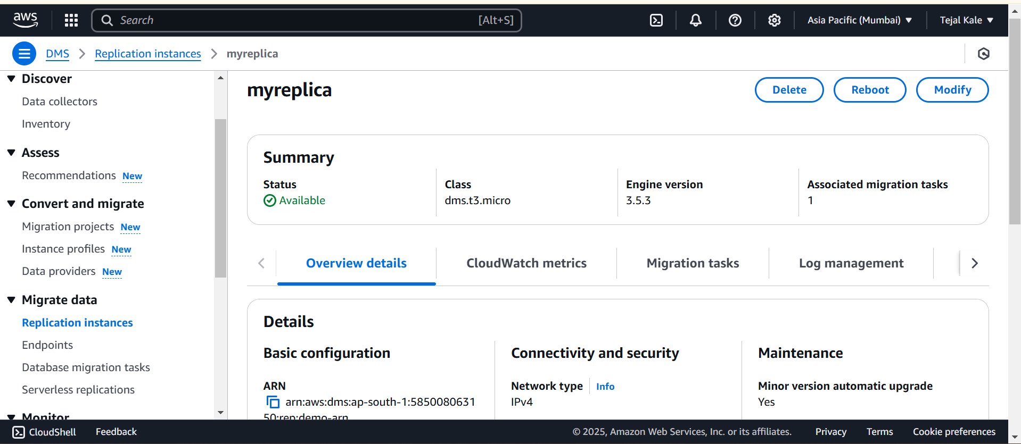

Step 5: Configure Source and Target Endpoints
Steps to Configure Endpoints:
- Navigate to AWS DMS → Click Endpoints → Create Endpoint.
- Create Source Endpoint:
  - Endpoint Identifier: source-mysql-endpoint
  - Engine Type: MySQL
  - Server Name: source-mysql-db.xxxxxxxx.us-east-1.rds.amazonaws.com
  - Port: 3306
  - Username: admin
  - Password: yourpassword
  - Click Test Endpoint, then Create Endpoint.
- Create Target Endpoint: (Same steps as above, but use target-mysql-db endpoint).
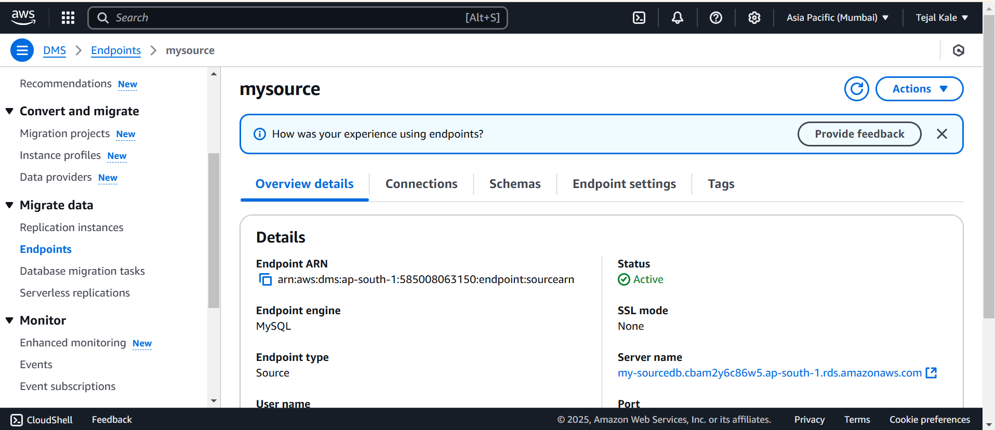

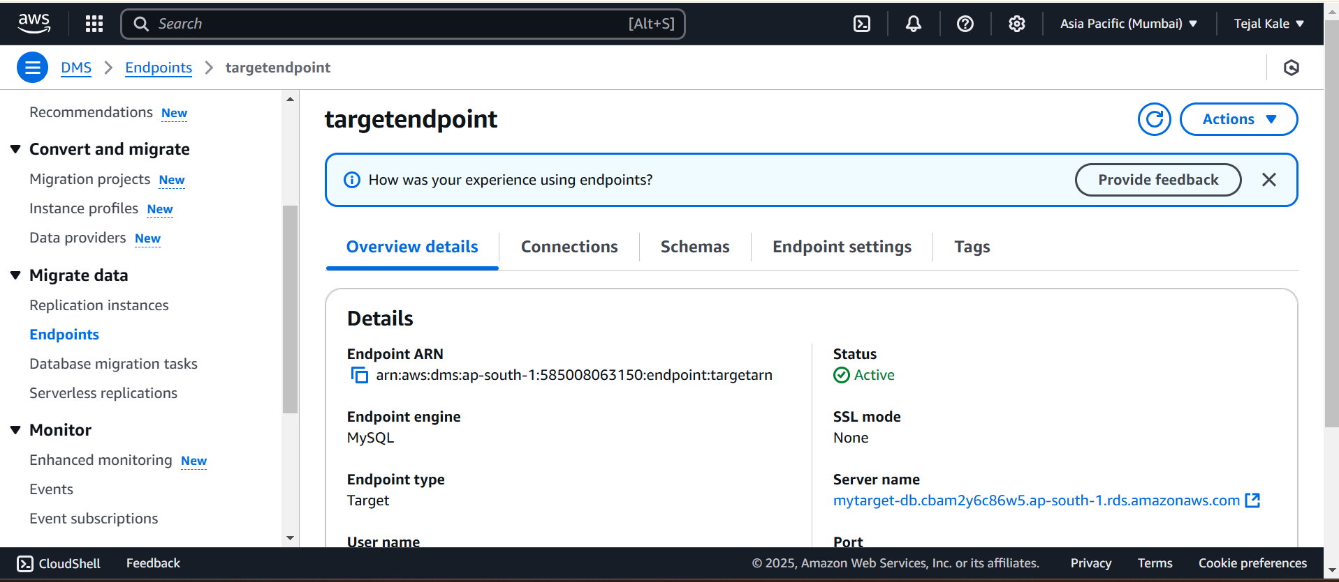

Step 6: Configure Firewall for the Replication Instance
Ensure that the replication instance can communicate with the RDS instances:
Steps to Configure Security Group:

- Go to EC2 → Security Groups.
- Select the Security Group of the Replication Instance.
- Edit Inbound Rules → Add:
  - Type: MySQL/Aurora
  - Port: 3306
  - Source: Security group of RDS instances.

Step 7: Create and Run a Data Migration Task
Steps to Create a Migration Task:
- Navigate to AWS DMS → Database Migration Tasks.
- Click Create Task.
- Task Name: mysql-migration-task.
- Select Replication Instance: mysql-replication-instance.
- Select Source Endpoint: source-mysql-endpoint.
- Select Target Endpoint: target-mysql-endpoint.
- Choose Migration Type: Full Load.
- Select Enable Logging and Click Create Task
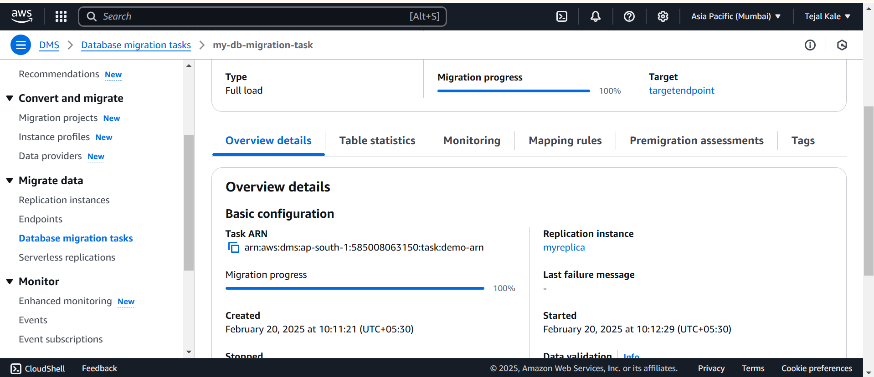
Step 8: Verify Migration Success
Verify Data on Target RDS:
- Connect to Target RDS using MySQL/XAMPP.
all records from source-mysql-db exist in target-mysql-db.
